### **Ideation Phase**

#### **Define the Problem Statements**

|  |  |
| --- | --- |
| Date | 4 JUL 2024 |
| Team ID | SWTID1720004076 |
| Project Name | Wise Wallet: Your Budgeting Partner |
| Maximum Marks | 3 marks |

**Customer Problem Statement**

|  |  |  |  |  |  |
| --- | --- | --- | --- | --- | --- |
| **Problem Statement (PS)** | **I am (Customer)** | **I’m trying to** | **But** | **Because** | **Which makes me feel** |
| **PS-1** | A busy professional managing multiple financial tasks | Efficiently track my expenses and incomes | it’s difficult to find a comprehensive and user-friendly tool that allows me to do this seamlessly | most existing solutions are either too complicated or lack the necessary features | disappointed and disconnected from my financial goals |
| **PS-2** | A budget  conscious shopper | Easily analyze my spending patterns | current financial apps lack customizable budget categories | they don't allow for specific categorization of expenses | uncertain about where my money is going and how to optimize my budget |

**Breakdown for PS-1:**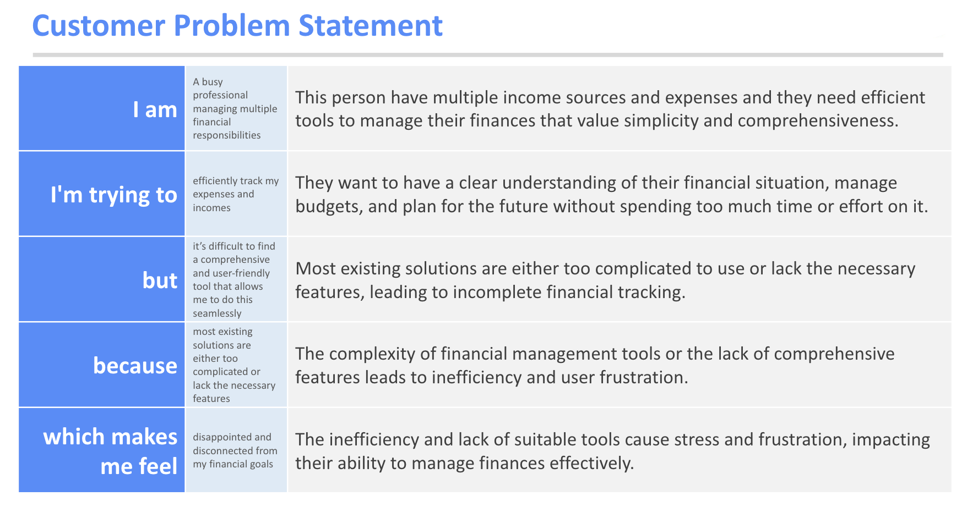

**Breakdown for PS-2:**